**Monotheistic Traditions:**

* Monotheism is believing in one God. The opposite would be polytheism. There is an alternative name to monotheism which is the “Abraham tradition/religion” because there is something quite interesting about monotheism. All of the monotheists seem to be somehow connected so you cant have monotheists independent from Abraham with one exception but otherwise monotheists are abrahamic. The exception I was referring to is in ancient Egypt, for a short period of time there seems to have been a monotheistic tendency. Its different than the monotheists we know.All you need to know is that the Abrahamic tradition could be taken as an alternative to the monotheistic tradition.
* Which are the religions involved in monotheism?

1. Judaism
2. Christianity
3. Islam

These religions are interrelated historically so if a buddhist tends to see these as very similar religions; from a distance they are.

* What’s the connection with Abraham? Why do we call them Abrahamic religions? In August of this year, we will be celebrating a feast, Adha.
* Sons of Abraham: Isaac, Ishmael. Who was the eldest: Isaac. But then theres a story about god asking Abraham to sacrifice one of his children and abroad takes one and goes to sacrifice his child but then god sends something else that will take the sacrifice on behalf of the son. But the question is, which of the two sons? Ishmael.
* Basically, Abraham had two sons. Same story is repeated in both narratives. In the Judaism, Christian narrative it says Isaac was the son. Islam, the Quran says Ishmael. Theres another thing, Muhammad is believed to be a descendant of Ishmael and Moses is believed to be a descendant of Isaac so you see both Jews and Muslims descendants of Abraham and of course each one has a version of saying it was my grandfather not your grandfather who was supposed to be sacrificed and then saved. Christians follow the jewish narrative. The christians have different meanings to the story. The primary story was that god was telling his people I don’t want human sacrifice as opposed to other gods, other civilizations around that would claim human sacrifice. For the christians, this is a symbol of Jesus; the lamb that takes place for Isaac is a symbol of Jesus who dies behalf on humanity.
* When we say Christians, Jews and Muslims are descendants of Abraham, do we really mean genealogical descendants; are they really his children? No, because lets assume when europeans reached new world there were ancient civilizations where the europeans also reached Australia and various places in Africa, of course these people aren’t descendants of Abraham yet many of these people became christians and then later on, many of them became muslims and jews yet they are not in any way genealogical descendants of Abraham.
* So, what kind of genealogical are we talking about? **Yet lineage is not absolutely genealogical. You could be a descendant of Abraham by faith**

**“and do not presume to say to yourselves, 'We have Abraham as our father'; for I tell you, God is able from these stones to raise up children to Abraham.” Jesus (Mathew 3:9) —>** today, when were speaking of monotheism as being abrahamic, of course were not talking about blood line. Jesus is saying God can make out of stones, children of Abraham. Do not boast for ebbing descendants of Abraham n a blood line, genealogical sense. If you really want to be descendants of Abraham, you have to be his descendant by faith. Adopt his faith rather than the blood line.

* When we're speaking of monotheism, if we’re having this discussion in west Europe or north America, quite likely the audience might say that you’re talking about something thats way too far, way too ancient and this is nothing to relate to us. Thats not so true, because more than half of the world population today adheres to monotheism.
* Monism and monotheism:

**Monotheists believe that there two basically different realities: God and the universe. Monists on the other hand believe that there is one reality: that of the universe, and the gods are of it.—>** two vs one reality. Monotheists say that there are two realties: created and the creator. Two separate vs one; the universe itself. In other words, the gods if and when they exist, the monists could believe in many gods and could believe in no god but they cannot believe in one god because by definition they become monotheists. When monists say that there are gods, they are just part of a greater reality which is the universe.

* One of the most repeated statements in the islamic faith is “Allahu Akbar”; God is greater. Its a comparative degree, Monotheists would say that God is greatest. In other words, what they’re trying to say is that in no circumstance you are in, we can safely say god is greater than the circumstance. But if you’re applying this to any circumstance, then it becomes a superlative degree. So the mere statement is an indication of two realities; there is god and something is lesser than god.
* As much as we say monotheistic is abrahamic, it is possible for our purposes to associate Monism with Homer. Monism is greater than simple Homism but we can make monism associated with Homism and speak of Homer because monism as we will be seeing in this course is associated with Greek thought and just like Abraham is the father of the monotheistic approach, Homer is said to be the father of the philosophical reason approach. Let’s for practical reason, equate Homer with Monism as much as equate Abraham with Monotheism.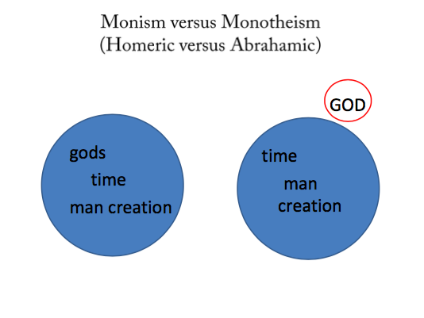

**The red circle refers to God and The blue circles refer to the universe. What might define the universe? Time, man, creation. In the monist approach, you have gods, time, man creation. The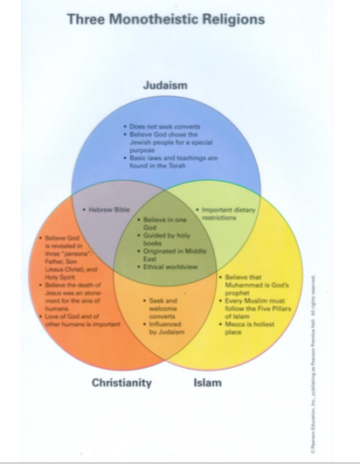 interesting thing is the word time, there is a being outside time in monotheist world, theres no being outside time in a monist world. In other words, there must have existed an instant in time or outside time when god existed but time did not. There might be an instant in the future where God still exists but time comes to an end and thats the Monotheist approach VS. time is infinite.**

**Infinite v. Finite.**

**Monotheists would say time is really finite; it has a beginning and an end.**

**When the gods are in the circle of monism in the universe, its because the universe is always there and in this universe which has always been there might have always had god. The clear key that would open up the difference between the two is the concept of time. Zeus is the son of Chronos, the god for time. The most important greek god has time above him whereas the monotheists would say, god creates time. The relationship between god or gods vs time is crucial.**

- God as watchmaker is saying that god makes the universe but then somehow leaves it or disassociate himself and then it runs on its own. He made a system by gravity and other things that will make the planets revolve and rotate so everyday the sun will raise. This is a theory, how will a such a theory be received by monotheists? Its not well received. God wont forget about the universe, he will interfere every second. Monotheists refuse this theory.

**The Ten Commandments:**

**\*\*For revolutionists, time is eternal and for creationists, time is finite but thats not the problem, the problem is that I don’t want you to get the impression that I’m saying that revolutionists believe in random evolution. Revolutionists say that because time is infinite, random things happen that have made the world look a little bit like we know it but then the power of revolution make life evolve from a bee to a dinosaur. so, its not a random process, revolution is not a random process.**

**According to the jews, theres a certain hierarchy in the commandments. \*\*\***

**Ten Commandments: (For Judaism)**

**\*\*\*Ten Commandment for jews, Jesus for christians and koran for islam. But someone would say why not Moses, Jesus and mohamad. Why do you go from one name to another? In fact, you’ll realize by the end of this session, theres a logic for naming them like this, theres something equal between the ten commandments, Jesus and the Koran as perceived by their own religions. ***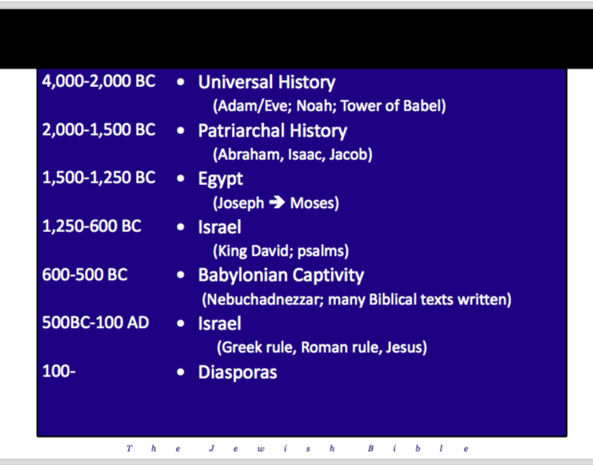**

**History as perceived by the Jews and the jewish scriptures. It could be divided into the following parts; the universal history with the story such as creation, then the patriarchal history in reference to 3 people who are basically the fathers of the believers of true faith( Judaism) and then theres a period where they were captive n Egypt, a period where they were free in Israel, and a period where they were captives again in the East(the Babylonian captivity) and theres a second phase in Israel where they were occupied by foreign troops by the greeks and the romans and its in this period where one of them, a jew by the name of Jesus makes some claims which will lead to a suppurate monotheist religion. And then theres diasporas which means the jews will be all over the world.**

The word scriptures could be referred to any holy book, the word bible is often referred to when referring to jewish scriptures. The word bible comes from a greek word Tavivlia which means the Bible which means book. But jews are not very happy with this name, christians tend to use it more than jews. The christian scripture is composed into 2 volumes, volume 1 is the old testament from the christian perspective, it matches almost exactly the jewish scriptures. So what the christians call the old testament is the jewish scriptures and hence the confusion, the word bible tend to be used. Jews are not happy with the Bible and are definitely not happy with the word old testament although both refer to the same book.

**Jews describe their book as Torah(law), Neviim(prophets) and Kethuvim(writings). The acronym of these titles is TaNaKh. Best name for the scriptures is TaNaKh. All 24 items on this list are referred to as books by the jews.**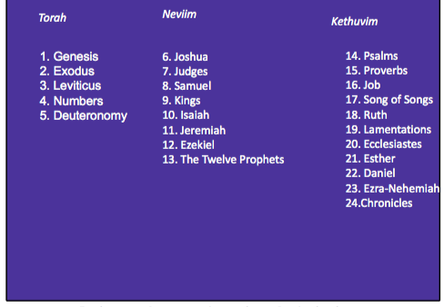

**As for Torah(law), it could be subdivided into 2 parts: part 1 having book1, part 2 having books 2,3,4,5. Part 1 is genesis, whats in genesis? The universal history meaning creation (Adam and Eve), genesis also has the patriarchal (Abraham, Isaac and Moses).**

**The second part (books 2,3,4,5) which basically repeat the same story 4 different times. The story of Exodus, story of the people of Israel going out of captivity in Egypt into Israel repeated in 4 different narratives. And then you have a set of books in the Neviim, the 13th one is the Twelve prophets, its basically another whole set of prophets compiled in one book with little information.**

**The Ten Commandments:**

**1. Hierarchy:** —> according to the jews, theres a type of hierarchy in the commandments; some commandments are more important than others. The ten commandments are a subset of

2. The mitzfot

613 commandants taken from the Torah —> whatever commandment god gave were collected by the jews and something called the mitzfot. so, the mitzfot is the corporus of the law. Within the mitzfot, the most important law are the ten commandments and then the Mitzfot a subset to

3. The halakah

It means the path that one walks and is a collective body of jewish including the mitzfot and other ones as well. so, 3 concentric circles and the heart of it would be the Ten Commandments.

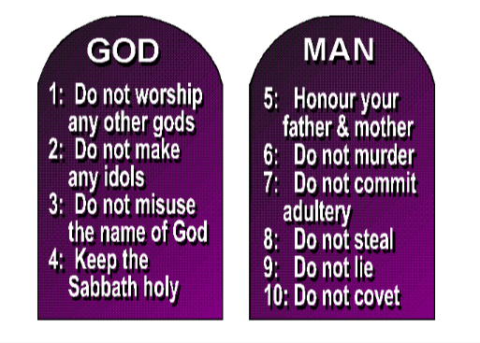

**2. Constitution:**

What makes a constitution different than other laws? In the constitution, its a place where one can derive the rationale(mindset) of the law. Although the constitution doesn’t speak out what the rationale is but the laws of the constitution themselves would speak out the rationale.

If you want to simplify these 10commandments, they could be divided into 2 tablets. **On one tablet circulating around the theme of god, and the other tablet circulating around the theme of humanity. The first tablet has 4 commandments and the other has 6.** **Sabbath means 7. When god says 7, he’s referring to the seventh meaning the seventh day meaning sabbath.**

- Just like constitutions are a central and important part of the law but are not all the law is are the 10 commandments.

- Jews would consider these commandments to not to be man made, from a jewish perspective, these were hand written by God. The jewish scriptures would say Moses went up to the mountains and received these tablets already written by the lord. And it was not he who heard these commandments and called the people to write them down; the power of god wrote these.

**Names of god in jewish scriptures:**

1-“ELOHIM” (plural form) is the first name for God found in the TaNaKh, and it’s used throughout the TaNaKh over 2,300 times. Elohim comes from the Hebrew root meaning “strength” or “power”.—> the IM mean plural. Elohim simply means gods. One of the name of god in the old testament is gods. God is gods. They refer to god as Elohim simply to mean one of two things: respect, or he’s greater than all of god of the world united. In their mindset, there are no other god but there are hand made gods that are not actual real gods. And its probably both.

2- YHVH is another name of God in TaNaKh. This name appears more than any other name for God in TaNaKh.

YHVH comes from the Hebrew verb to be and is the special name that God revealed to Moses at the burning bush, “And God said to Moses, I am who I am; and he said, thus you shall say to the sons of Israel, I am has sent me to you… this is my eternal name and this is how I am to be recalled for all generations” —> the word “I am” is a phrase but then his name is “I am”.

You cant have the verb to be and treat it as a noun but interestingly, “this is who I am to be recalled for all generations”, he then uses the word I am but not as a noun.

God’s most intimate word is “I exist”, its about his existence. And anyone who gets a spiritual experience would come back and say that god has been there all my life. In other words, the name I am is related to the identity of who god is in terms his spiritual experiences.

**Features of God in the Jewish Scripture:**

**These 5 features appear first in the jewish scriptures but then are confirmed in the christian and islam. This could be features of god in monotheism as well.**

1- The absolute transcendence of God (not in the cosmos —> god is not part of the universe; he’s above the universe. The first people in the world to elevate god from his status of monism to monotheism or within the universe to be created are the jewish people. They claimed that god is independent of what he claims.

2- God’s freedom is absolute —> think of the ancient greek word, will not have god as being completely free. They have the gods but they are not free. The mere fact that they have more than one god becomes territorial. There isn’t anything outside the control of god.

3- God is a personal God—> his characteristics are personal not like the sun. All features of humanity are available in god such as passion, mercy, love, tenderness, power. God has a mind not a software. And he addresses us personally.

4- God proclaims himself within history—> think of the greek civilization and other civilizations that speak of the Gods using metaphors. A greek wouldn’t mind inventing a story that conveys wisdom to us but a monotheist wouldn’t do that. From a monotheist perspective, Stories that convey wisdom are real stories.

5- God gives commandments (relating both to morality and to society)

**Jesus:**

- Jesus was a jewish man, he lives according to the jewish law. At some point, he makes one claim that endangers his life. The source of this lecture relating to Jesus is basically the christian new testament. There are many other sources that would portray Jesus otherwise. But what were interested about these religions is that were trying to see how these religions perceive themselves rather than by others. Were only interest in the self proclaimed reference.

The source is The Christian New Testament which could be divided into 3 parts:

**Christians have 2 volumes; volume 1is TaNaKh (jewish scriptures), volume 2 is christian scriptures. The only difference between the 2 is the order of sections. For the jews, its TaNaKh. For the christians it’s TaKhNa. Volume 2(New testament) has the following three sections:**

I- The Biography of Jesus—> same biography repeated 4 times. They each have their own focus.

The Four Gospels

Mathew

Mark

Luke

John

II- The Early Church—> the followers of Jesus would live independently of him.

The Acts of the Apostles

The Letters

Letters of Saint Paul

other letters

III- The End —> not only its a conclusion, but its also about the end of the world.

The book of revelation

Brief Summary of the Life of Jesus as projected in the Gospel of Mark (repeated in Mathew, Luke and John with slight variations)

* Man named Jesus; carpenter
* Was baptized and tempted but did not fall
* Performed miracles
* Taught using proverbs
* Gathered a small group of disciples
* Claimed to be the messiah
* Claimed to be the only son of god
* Taken to trial
* Killed on the cross
* Rose from the Dead

Then he makes the 2 claims; he claims to be the messiah, and he claims to be the only son of god.First claim: According to the scriptures, jews were waiting for a savior to come and then Jesus says I’m the one who fulfills prophesy, you’ve been waiting for me. But this was not the sharpest claim that he’s made. Second claim cost him his life, he was claiming basically that he is god.

Two main themes:

1- Jesus is the awaited Messiah—> according to mark, then Jesus and his disciples went away to the villages near Caesarea Philippi. On the way, he asked them, “Tell me, who people say I am?” “Some say that you are John the Baptist,” they answered; “others say that you are Elijah, while others say that you are one of the prophets. “What about you?” He asked them. “Who do you say I am?” Peter answered, “you are the Messiah”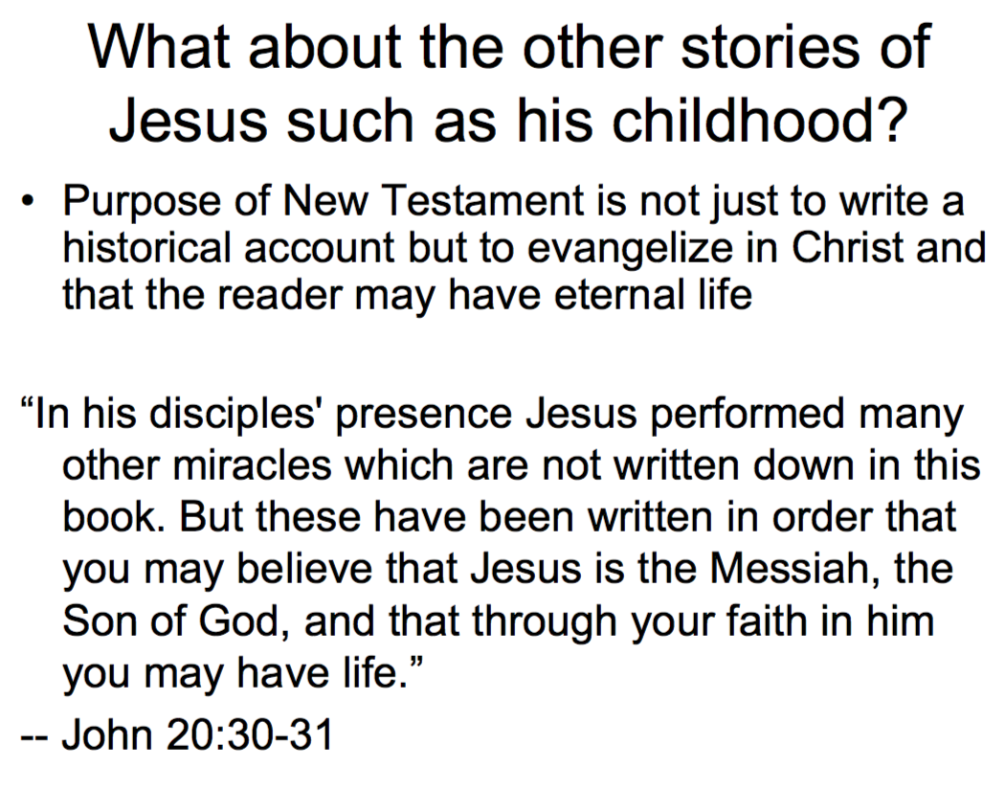

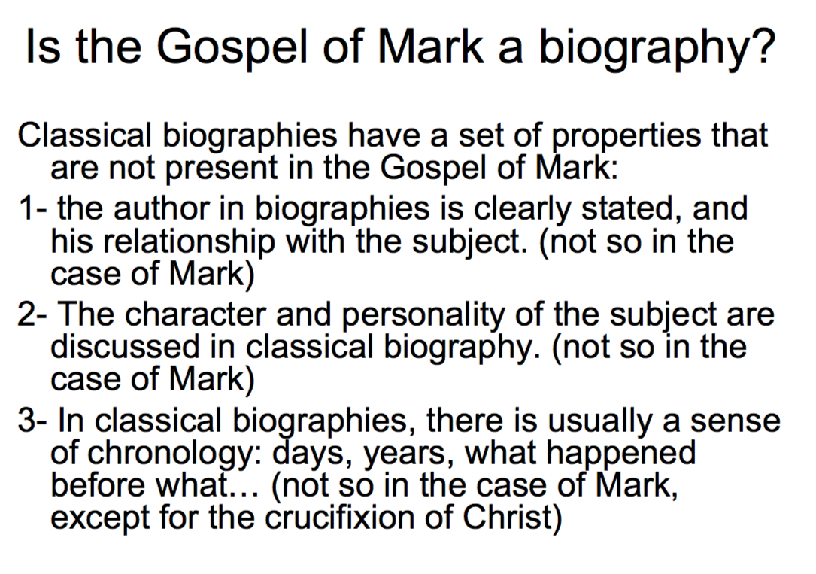

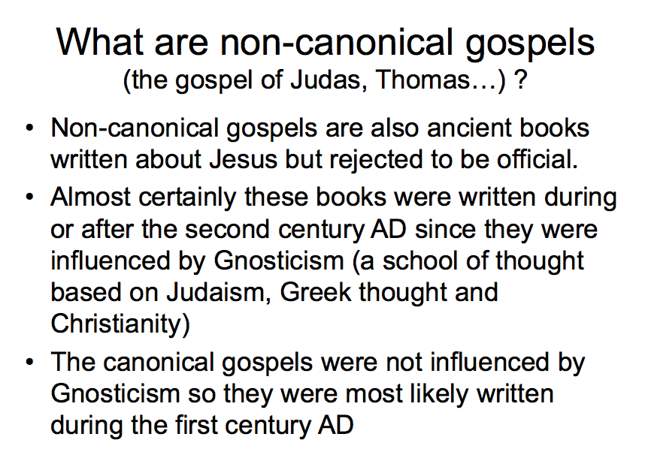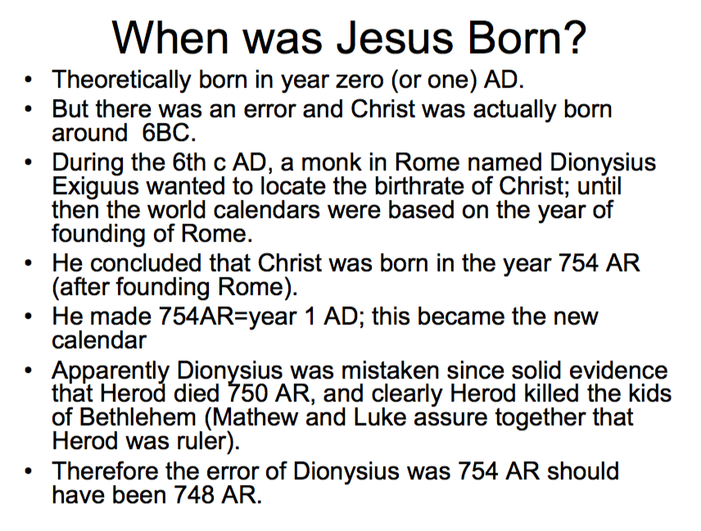

2- The divinity of Jesus

**As for the divinity of Jesus, anything could be made in more than one way. One way of making a claim is explicit, the other way is indirectly not so straight forward. For example, I can come into this class for the firsts session and tell you good morning, I’m your instructor; this is an explicit way, I verbalize the word instructor. Another way would be that I say to you that I’m authorized by AUB to lead this discussion and lectures, I’ve been authorized to write exams questions…; this is an indirect way. I didn’t use the word instructor.**

**How did Jesus claim his divinity? Explicit and implicit way but much more implicit than explicit. Sometimes he’d directly say he’s god and sometimes not that directly.**

1- Mar 1:1 this is the good news about Jesus Christ, the son of God

“The son of god” is a clear statement about the divinity of Jesus. Jews never used this word to an individual. A society might be “The children of god” but not a single person. —> from a jewish perspective, this is clear that he’s making a claim that he’s a son of god as in being equal to god. Jews at the time and jews today would refuse such a statement.

2- Mar 2:28 so the son of man is lord even of the sabbath —> son of man could be understood in this sense. You cant expect to find a family name Beirouti family from beirut, you can find a Tripoli family in Beirut. When Jesus and the Bible referred to him as son of man, that was so unusual, he’s not supposed to be the son of man thats not the sharpest claim. The son of man is lord even of the sabbath; the seventh day is day of the rest. The sabbath belongs to the lord and here someone is claiming he’s the lord of the sabbath. He wold forget his sins but when he hears his sins, jews would get mad because god is the only one that can forgive sins.

* **CS Lewis Trilemma:**
* wrote Narnia; used to be a professor.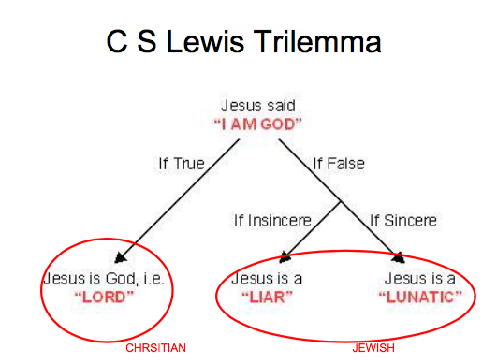
* At a later age, he became a theist and a strong christian. He became an apologist; defender. Much of his writings, after his conversion would be apologetic. One of the things he would pick up from the divinity of Jesus is that he says: Jesus says “I am God”, he said it in an explicit and implicit fashion and there are only 2 options of this claim; true or false. Lets say its false; there are still 2 options: sincere or insincere false claim. By sincere, we mean he thinks he’s god but effectively he’s not. He has some serious psychological problem that makes him think someone who is not. By insincere, if he knows that he’s not god but somehow he’s trying to deceive the world by saying he’s god. In this case, he would a liar and a lunatic. There would be the other option. What if this claim is true, then he would be truly god and must be worshipped as such.
* The jewish people are saying he’s gone mad because he’s making this claim and he’s not god. Others were saying he’s a demonic person, he only speaks lies. He’s either mad or a liar.
* The 10 commandments of the old testament would be summarized by 2 commandments by Jesus: love god and neighbor. He summarizes them by using the word love. This is the synthesis by jesus.

**Koran**

* All three religions have something in common which is especially visible in the last 2 is that they were uncreated.
* Jesus from the christian perspective is uncreated; Jesus existed four times not in a human body, but he existed in an entity as a god within god before the creation of time.
* The Koran existed before time, not really as a coequal or a competitive to the koran but the truth of the koran existed even before the creation of the world. The uncreate part of god takes a human form and the uncreated word would be pronounced on human tongues and that would be on Muhammad's. There is a parallel especially in the last two namely Jesus and the Koran equated as being uncreated.

uncreated= Jesus—> Mary( source).

Koran —> Mohammad(source)

Mary and Mohammad could perceived as parallels because its thought them that the uncreated become concrete tangible. This is a very specific theological comparison because there is a Mary in the Koran and there is a Mary in the Bible. Were looking at the human person through which the uncreated becomes known and that would be Mary vs Mohammad.

* Lets assume I have a great grandfather who was born in a village in Lebanon and traveled to Mexico and then went to America made lots of money and thats all I know about him and that he had a textile company. Then a researcher comes and tells me do you want to know the real story of your grandfather? I found some documents, he left here because he was afraid that he will be taken by the ottomans to take him to the military, escaped the boat and found his way to Italy and found another boat and he lived in new York for quite a while and worked as a portrait and then he was told there was a good business…… (Different story.) Notice the little info vs the concrete info from the researcher. Some things were correct, some things were wrong, some thing were given more details. Lets apply this wisdom to what the koran claims. It claims to be the real story. You jews, you christians, you knew part of the story. Some of it you got it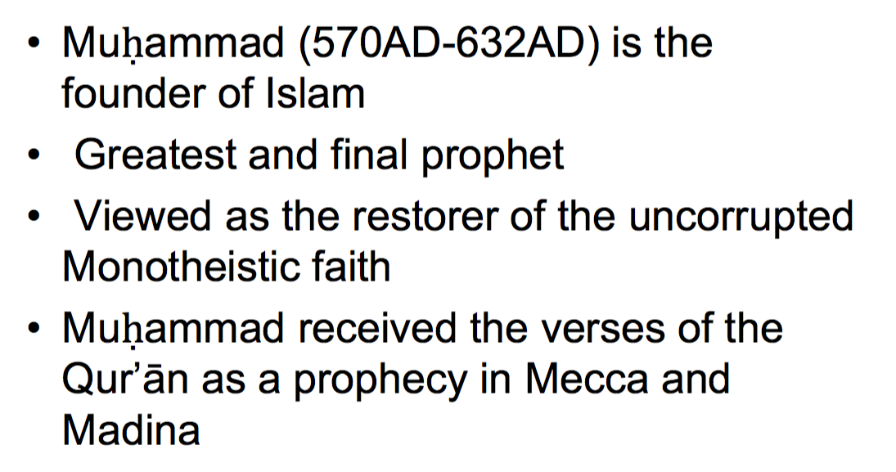 right and some of it you got it wrong and some of it you got it missing and let me tell youth true story. The true story is an uncreated story, its not a historic story. I will tell you that Jesus never claimed that he’s the son of god or a divine.
* The person through whom the revelation brought forth is Muhammad who died 632 based on the christian calendar. The Hijra calendar begins in 622. Muhammad is perceived in Islam as the greatest and final prophet.

Islam stresses the oneness of god.

* The word Koran would translate into “The Read”;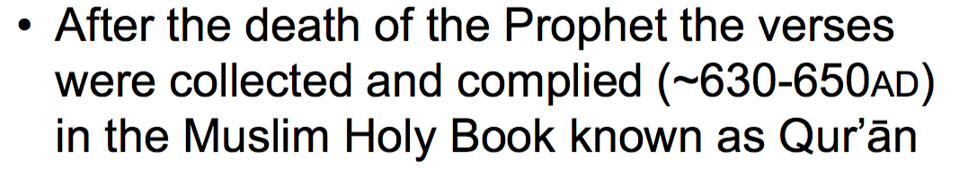 superficial translation. The more accurate would be “The Recited”.
* The fact that the first words revealed to Muhammad is Read is often used to prove islam’s emphasis on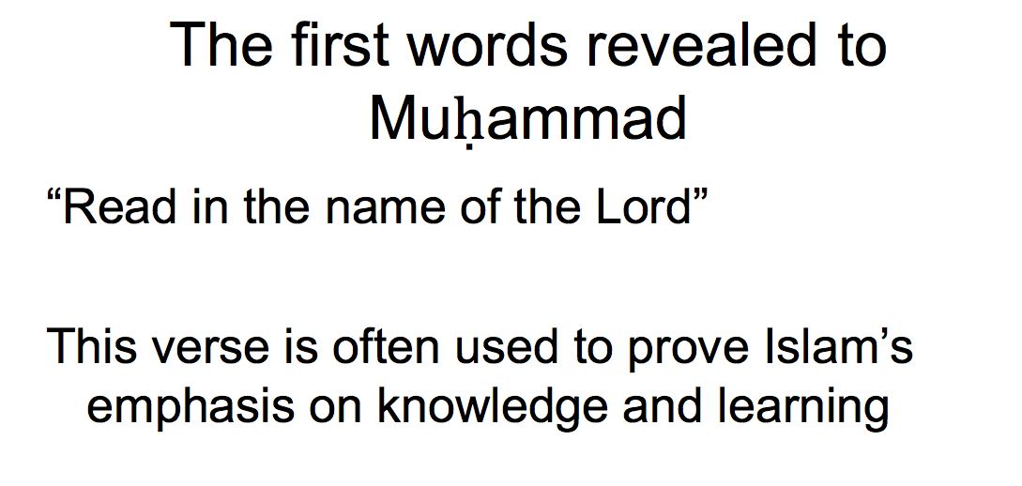 knowledge and learning.
* Jesus is mentioned in the Koran, his name is Issa. He’s a great prophet in the Koran, it was corrected. but, he’s not greater than Muhammad from an islamic perspective.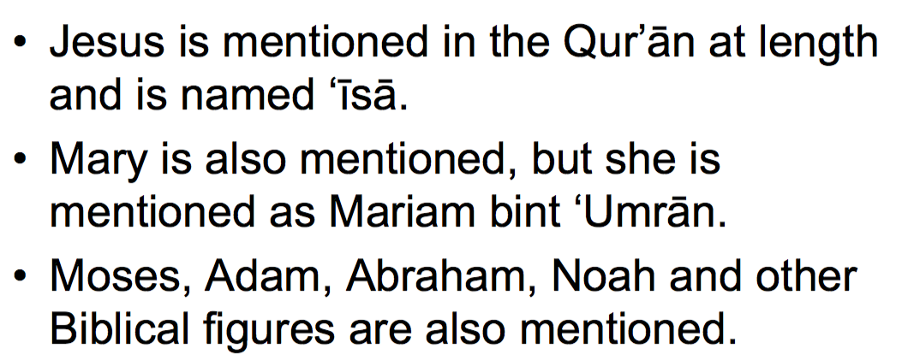

- claims of the Koran come from the koran itself as much as Jesus’s claim would come from Jesus himself.

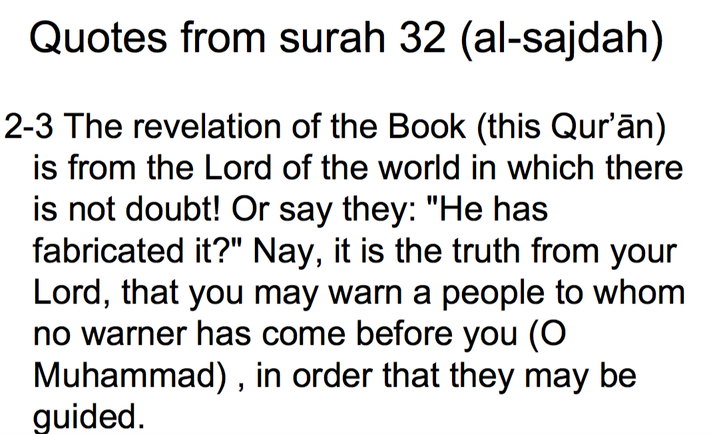

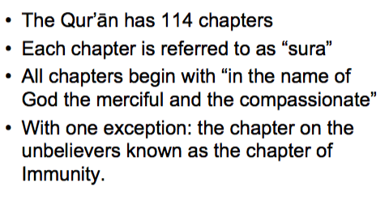

**The Koran is saying that there are some who would say that Muhammad has fabricated these; its just a man made book. This is the truth from god and you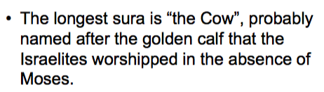 should warn the people that no one has come before you to warn them about this conceptions that they have.**

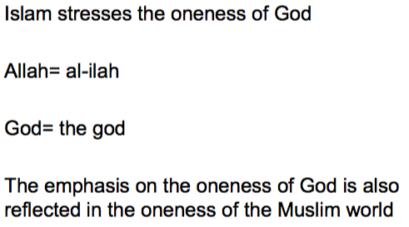

**Any monotheist religion by definition stresses on the oneness of god. Islam does it more than any other religion and whenever you have a society looking at a trait, you would expect that this trait would fall upon the society. If you’re focusing too much on something, some part of it will really fall down on you.the oneness of god emphasized by islam folds on islam in a way that there is some focus on the unity of society. What I’m not saying is that islam s a unified religion in every aspect, christianity has diversity and nothing about unity. Islam is a religion and a system of life covering all aspects including politics as opposed to christianity which is not into politics.**

**Al ilah: the god**

**Introduction to Greece and Plato**

Greek thought is not the only reason in the world, they’re not the one to claim that they can monopolise reason and logic thats also very true but for good reasons, we have chosen monotheism and reasoning as the basis of the course for faith and reason. The monotheism is the most dominant faith all over the world and half of the world are adherers to monotheism. More than half of the world are adherers of greek reasoning.

- “We are all Greeks”- Percy Shelley—> what did he really mean? Were all influenced by greek thought, intellectual reasoning. He doesn’t mean we are all politically greek, he’s not referring to religion nor ancient Greece or the contemporary greek. He’s not making an ethnic claim, he’s not saying were linguistically greek, his language is english. What he’s saying is that we, the western world, has established its thought by basing it on greek reasoning, in terms of philosophy. Arabs for one are inheritance of Greece, particularly Aristotle. So, when we says we are all greeks, he’s referring to the western world in terms of philosophy and intellectual reasoning.

* “Greece was the mother of Europe; and it is to Greece that we must in order to find the origin of our modern ides.”- he's saying that in order to understand modern ideas, you have to look at ancient Greece. Both of its negative and positive things that it holds, Greece is the foundation of modern thought in the western and other parts of the world.
* “The safest general characterization of the European philosophical tradition is that it consists of a series of footnotes to plato.”—> All the European philosophical traditions according to whitehead is nothing more than footnotes to plato. The first and larger of these footnotes is Aristotle. Plato was the teacher of Aristotle. Its a question of footnotes; everything is footnotes. The greatest foundation would be plato.
* Socrates didn’t write any books. Socrates was the founder of this trinity of philosophers; he taught plato and plato taught Aristotle and Aristotle taught Alexander the great. What does this signify? Alexander helped in spreading the thought of these 3, making them universal. He was a ruthless conquerer, he made philosophy more available. From these 3 names, the middle one is plato, the middle one is a connection between the first and the third and when you say he’s the foundation of philosophical tradition, you might basically implement all of them together. Were there any philosophers before socrates? Yes but philosophy was escalated to a different standard by these 3.
* **Story of socrates:** he was accused of corrupting the minds of the youth and he had to defend himself and did a fascinating job. He accepted the decision of the court( death penalty). He did not write anything, but what we know of his teachings come from plato. Scholars were able to c when plato quotes socrates, theres something about Socrate’s logic was a bit different than plato which makes scholars believe he’s honest. He distinguishes the 2.

*Plato:*

* Plato speaks of the allegory of the cave. Imagine there were prisoners inside a cave and these prisoners have never been free; they were born in prison. Their knowledge of the world is so minimal that they only know the wall in front of them. But It happens to be theres a fire behind them; they see the light. There are people who would walk between the prisoners and the fire and these free people who walk on the roadway carry something with the would project their own shadow on the wall. The prisoners get to see nothing but shadows. Prisoners only believe in the reality of the shadows then one of the prisoners release himself; eventually he finds himself outside the cave. The first thing that would happen to him is that either hell become blind and its very painful. He would say that all he’s been seeing is shadows now he knows what a tree looks like. What would the next step be? As soon as we discover knowledge, we want to share it. He went back into the cave to tell the prisoners what the truth is. knowledge is always resistant, truth is always resistant. Where did this metaphor come from? The story of socrates. He’s just one orderly person, he frees himself and thinks in a different way and understands certain reality that others don’t understand. He went and told people and but they killed him for it. Another thing he expresses is the theory of forms. Lets assume the prisoners were seeing shadows and lets call them shapes. They were seeing shapes. And lets call what he sees outside forms. Now he understands the difference between shapes and forms. According to plato, one has to understand the forms in order to understand shapes. If you understand the concept of the table , you hold the keys of understanding table-hood and thats enlightenment. By form and shapes, he doesn’t mean form as a physical form and shape as a physical shape, he’s using these to discuss ideas. Its just an idea. When you understand a key concept behind an idea, you’ll understand the key concept of its application.
* Which comes in first? Particular or general? General which is the tree outside. If you understand that one tree, you’ll understand the theory of forms. The tree is something physical but if you understand the form of time, you can understand all the different notions.
* Before plato and socrates, there were 2 different philosophies. One if about permanent, and one about the change. Plato reconciles these 2.
* “you cannot step twice into the same”- **Heraclitus.** —> this is about change because the water is changing, you cant really step into the same river twice. If you dip your toe in a river and then dip it again in the same river, the river has already changed.

**Vs**

* “what exists is uncreated and imperishable for it is whole and unchaining and complete” -**Parmenides**—> nothing in this universe changes. Everything remains the same.

The connection between the two: theres something that changes and other things don’t change.

The form doesn’t change, but the shadow changes. Theres one man that doesn’t change but we all are images that change.

Plato reconciles both notions:

Reality (form/ tree) Appearance (shape/ shadow of the tree)

Real Shadow

Being Becoming

Eternal Temporal

Universal Particular

Intelligible Sensible

—> the universe itself is changing. That being up there would be unchanging.

Monotheists would say theres only one being which is God.

Basically, its physical vs metaphysical but metaphysical could be changing.

As a conclusion, he speaks of demiurge, which means artisan/craftsman. Reality has to have an organizational force which doesn’t have to have a mind. It doesn’t have to be like god in a monotheist world. This force is behaving like an artisan without necessary having in mind.

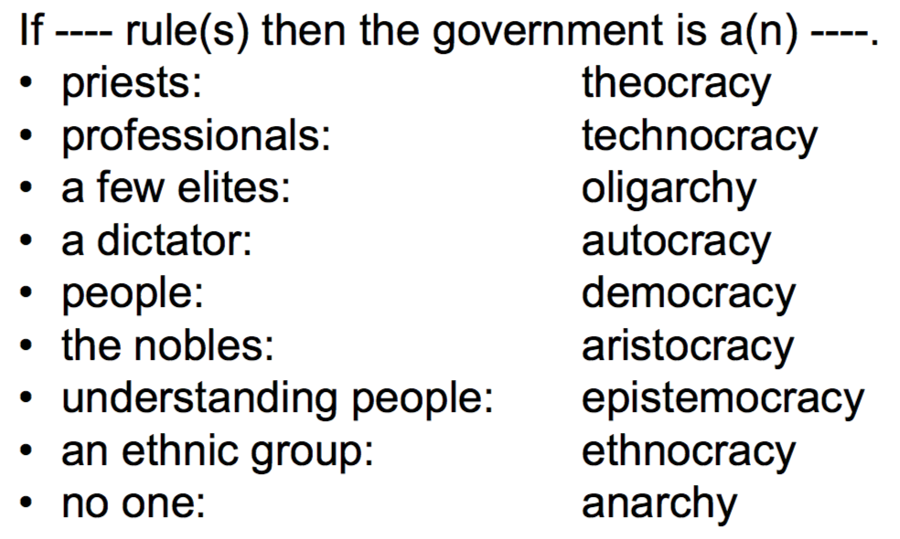

* The republic of plato

**Who should rule a society?**

For plato, a philosopher should rule a society because a philosopher can interpret forms. the form is an idea. Philosophers have ideas, he knows whats best because he knows some things that the rest of the society does not know. His mind goes back to his teacher Socrates.

There is no word for a society ruled by philosophers, but we simply refer to such a governance as “Platonic” rule; its an ideal rule based on an idea.

* One last idea about the cave, in this metaphor, one sees a a hierarchy of knowledge. If the prisoner doesn’t go out of the cave he only sees a fire. Thats some level of truth that he can learn from. The greater level is when you see a greater fire which is a sun. Thats why we have some scientists that know little and some scientists that know much.

*Aristotle:*

-Aristotle had the luxury of critiquing plato.

**God**

For plato For Aristotle

Artisan Unmoved mover

Demiurge Initiator

Does not create but puts order Generates by motion

**Difference between Plato and Aristotle:**

1. For plato its general to particular. For Aristotle, its both. Aristotle is saying plato might be right but you cant say that all knowledge come from general to particular, theres some knowledge that come from particular to general. Plato is saying no matter how long you stay in the cave, theres no way you can understand the shadows before going out and seeing the reality and then understanding the shadows. Its as if Aristotle is saying well thats true but its not the shadows that we look at, we look at tables for example. If I look at 1000 tables, I can conclude what “tableness” is about. Science is based on observation but then applying this conclusion to these examples to verify them would be platonic.

2. Plato speaks of artisan or demiurge; someone that does not create but puts order. Both are monists; speak of the greatest good in the universe. For Aristotle, everything moves in some way. If you follow the chain, there must be an initiator and that would be the closest to what the monotheist later call God. This generates but still in the monist world.

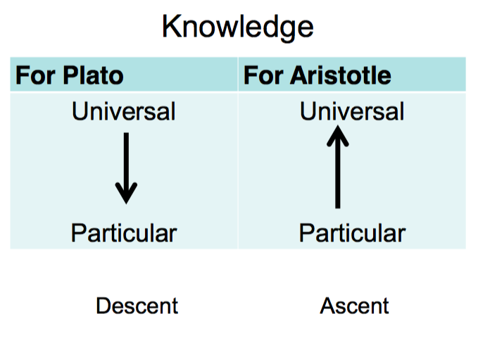

**Augustine**

**“What indeed has Athens to do with Jerusalem?”**

- Who was the author of it? Tartoulian.

* What is meant by this quote? Its a total divorce between faith and reason and the first person to make a serious attempt in gapping is Augustine.
* Features of Augustine:
* “believe in order to understand, and understand in order to believe” —> if faith is true, reason should not be in conflict with it and one should not be afraid of reason. No one before Augustine removed this barrier between faith and reason. Philosophy is concerned with everything, now that you have monotheistic faith, philosophy will evolve itself in monotheistic faith and define and discuss its foundation. Its not based on revelation, what are these religious people? Faith is helping these philosophers in giving them new material to discuss but when philosophy gives faith or religion a new thing to discuss is the interesting thing; it gives it a new methodology a new way of thinking, a new way that will go hand in hand with the revelation and types of methodology.
* The dynamic of experience and reason. Experience is concrete and it brings material for thought, which leads to newer understanding. —> faith should be challenged by reason for the sake of better faith. If you think of a total divorce between the 2, you will not be helping reason.
* Interesting features of Augustine: canonized **Saint**(christians believe that every single good Christian is a saint but not every christian is proclaimed to be a saint) , **philosopher**(if at all tis possible to remove every trace of faith in monotheism and search only for the philosophy in augustines literature you'd still find an important philosopher standing up. This philosopher founded many movements that emerged in the 16,17,18,19 centuries such as existentialism, phenomenology, cartesian and many other movements.) , **genius**(he wrote many books) , **theologian**(he studies religion and is able to express his religious thought in a philosophical language. He was both a philosopher and a theologian), **bishop**, **lived at time of fall of Rome**( Rome was an empire that got a nickname of The eternal city. The people fanciest Rome thought this city would never be taken by enemies except for the year 409 it was invaded by the barbarians; people of north Europe uneducated, unreligious. This made Augustine write his second book), **wrote intensely**(93 volumes; 270 letters; 400 homilies).
* Augustine wrote his own auto biography what makes Augustine **the first autobiographer**? Augustine wrote about his sins not only about his good deeds. He’s speaking about the most shameful things on his own measure and he’s putting them to the Public. He’s thinking out-loud.
* Augustine fought against: **Marcion**: God of the old testament is not the same as the god of the new testament.

**Mani**: sex and marriage are sources of evil

**Dentists**: separation of church and world

* Cogito, Ergo Sum ( I think therefore I am)—> Cartesian philosophy, Descartes. Descartes was a mathematician and a philosopher. Mathematics has a very clear constructed type of thought that will make u very clearly from one step to another that will make u come up with the conclusionon. When it comes to philosophy, sometimes you are able to go from one step to other times not and you come up with a conclusion and somehow verify it and both cases theres something abstract about the numbers, you cant touch or hold the numbers and very much so with philosophy. however, mathematics you can always demonstrate it whereas philosophy is not so convincing.
* This person was very influenced by Descartes and actually cogito ergo sum is also influenced by Descartes. He started by saying I’m a mathematician and let me doubt absolutely everything, theres nothing I know, I’m not certain about anything. For the sake of this argument, on a rational level there ought to be a determination to my doubts which is the fact that I’m doubting. Now that I doubt everything, the one thing I know is that I doubt and I know that there is no area that I’m not doubting but what is doubt? Its a mental thing. Now I know that my mind is functioning. Now that my mind is functioning, I know that I have a mind but the fact that I have a functioning mind, I am thinking but not regardless of my existence. If I’m thinking, I could be wearing anything but I can not not exist and thinking. In other words, he’s saying that this is what existentialist say I am therefore whatever… I am meaning I exist. The starting point of thought would be existence. The starting point of Descartes would be thinking and then you derive existence. actually, Descartes’ approach or cartesian approach and existentialism are strongly found in Augustine’s writings.
* Augustine seeks the truth.

finds answers in god through god’s creation

approach: existential/ non dogmatic

* “these are tentative theories… not downright assertions”
* “Can any man say enough when he speaks of you? … even those who are most gifted with speech cannot find words to describe you.” —> book 1 part 4( you are the most … end of page) —> its a description. He’s addressing God which makes the book some sort of a prayer. His confessions and praises are to God. Is he changing or unchangeable? He’s both at the same time.

*Selections from Augustine*

- What is sin? How would you define sin? Betraying someone. What kind of betrayal is sin? Betraying god or yourself or others.

- Is there sin in the monist world? In the greek world? Would the greeks perceive themselves as sinners? Sin is very much associated with god or the law. By law we mena, scriptures. But the greeks wouldn’t have a Scriptural law, they would have a Mundane law but. Not a divine law. Their sin is not really a sin, it’s more of an error or a mistake.

- The greatest power for a monotheist is God. The greatest powerful the Monists is the universe and therefore the order of the universe is what really counts. Anyone who violates the order of the universe, then you will be mistaken its not really a sin. Sometimes, if you kill someone unintentionally is this a sin or not? According to monotheists, what really counts is the heart. If you do something unintentional ,you have to always think of god, which makes god more of an interactive being.

* The most terrible sin of Augustine was stealing pears, because he did not like pears. Let’s assume the tree of pears that he stole was not picked up by his owner; the owner didn’t want the pears, they just fell off. Would this still count as a bad sin? Yes, because the sin doesn’t have to do with the outcome but has to do with the heart. So this guy was stealing pears, the most terrible sin because he did not like pears. This opens up a different question about the nature of sin. Theres something about sin that theres something nice that attracts people; sin uses nice things so people fall into it. What if a person is doing things not for the nice sake of it, the person is only looking at sin for the sake of god.. people fall into sin when they’re looking at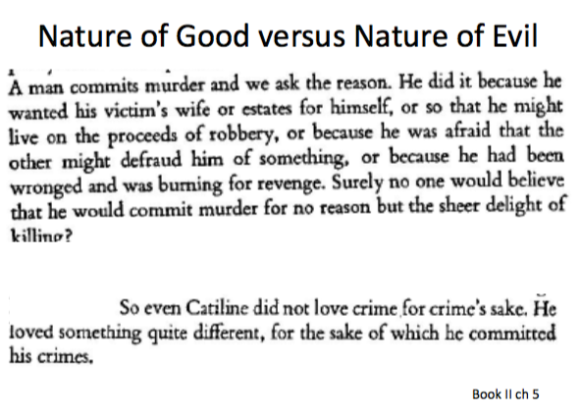 something good ; they would crave for something nice, good for that they commit a sin. What if someone isn’t looking at something nice?

**Good vs evil:**

* people lie because they want to project something about themselves thats not there; to appear something that they are not.
* Evil and good aren’t really the same.
* HE was getting some sort of pleasure out of it and for that he was tempted. Lets assume, Augustine loved the pears and every time he would walk next to the pears , he would be battling inside himself. The sin here is less horrific than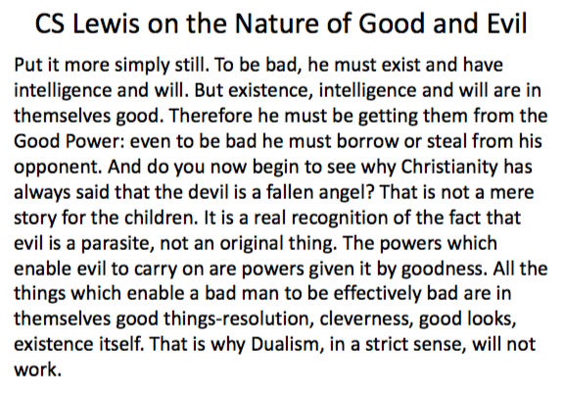 someone stealing a pear that he doesn’t like.
* According to CS Lewis, Evil uses goodness; is a parasite on goodness and not vice versa. Evil cannot achieve itself without stealing something from goodness And a key to sin and evilness is lying. They’re using the goodness of the enemy so that they fulfill their goal and thats something that the evil rely on goodness and not the other way around. Christians based on jews would speak of the devil as a fallen angel.
* **The devil of a fallen angel** makes us think that the devil is much less than god. Dualism doesn’t exist. What is dualism? Certain type of religion that believes that good and evil are two and equal. For a monotheist, dualism doesn’t really work; you’re not stuck between good and evil, good is the creator, evil is a corruption of something good that was created. Evil uses the goodness.
* Story of the fallen angel: god has his angels, one of the angels that carried light, Lucifer, this angel thought of himself as greater than god and rest of the angels. Rest of the angels battled with him and there him out from heaven. Michael when he saw Lucifer wanting to sit on the throne of god, he told him who is like god? How dare you? And since that moment, Michael got his name; someone who defends god at any price.

*Knowledge of god to prayer or prayer to knowledge of God?*

* If you want to pray for god it means you have to know something about god; you cant just have faith, you have to have some understanding to fulfill your prayer. Whereas if you take the other way around, I want to begin by knowledge, but you cant achieve knowledge of god on a purely intellectual level, you must have some sort of spirituality, grace fro god above in order to know who god is and activate your prayer. Its really strange, there must be a starting point somewhere and have faith and then they would go hand in hand.
* He wants them both to be together, rather than one being over the other.

*God or god?*

* small “g” is for polytheists.
* Big “G” is for monotheists.

*Origin of Sin?*

* One thing that fascinates Augustine; he would discuss that trying to see where it comes from, it doesn’t come from God, it comes from the devil but it also comes from the human will and freedom. The story of the fallen angel relates to freedom; the angel was free. Muslims would say angels are not free but genies are free. Christians and jews wouldn’t say that. however, angels were free but they wouldn’t use that freedom because they know what would happen if you abuse the freedom. (Lucifer)
* These sins affect the soul and the affection of the soul is most horrific because it might pollute the soul of eternal light. The freedom that we have is not external.
* God did not create evil, god created freedom which allowed the growth of evil.

-**Is law a convention or is there something deeper than a convention in it?** Convention is for example on Monday, well agree that our class will be at 7 rather than 8; the law for that Monday.

* Natural Law. According to Augustine, theres a law that’s written in a mans heart that cannot be erased. Is this conventional? Its not, because its written in your heart. The law has to be written somewhere in the conscience. By natural we mean they are somehow within us, we don’t learn them from society. This is the natural law which is different from law of nature which has no freedom. Humans don’t always achieve natural law.
* 3 A Formula: referenced to 3 people who’s names begin with the letter A and they work a lot on the natural law. The 2nd is Augustine. The first is Aristotle, 3rd is Aquinas. The 3 A’s are people who framed the majority of natural law but they did not exhaust it. Natural law is based on trying to understand the purpose of nature. Why did nature give me a body, mind…? Not every natural desire is considered natural law.
* Catholic means originally universal but as a christian denomination means the catholic church. When he speaks bout catholic, he doesn’t mean the church of Rome as we understand it today; thats part of what he means.

-In the life of Augustine, he underwent 2 major conversions. First conversion was an intellectual conversion at the age of 21. Second at the age of 31. He comes across a text by Cicero, which was a politician. Among the things he’s written, he’s written something about wisdom. He’s asking people to hold wisdom as the highest value.as opposed to that, someone who converts to become a cicerian, on an intellectual level, his conversion was from what to cicerian: if you don’t value wisdom, you value power. Power vs wisdom, which one goes above what? Socrates he was taken to court and his wisdom cost him his life.

**Hagia Sophia: holy wisdom—> divine wisdom**

**Philo sophia: friend of wisdom—> human wisdom**

**agappi—> universal love**

**eros—> romantic love**

**philia—> friendship —> think of wisdom as a friend and not romanticise.**

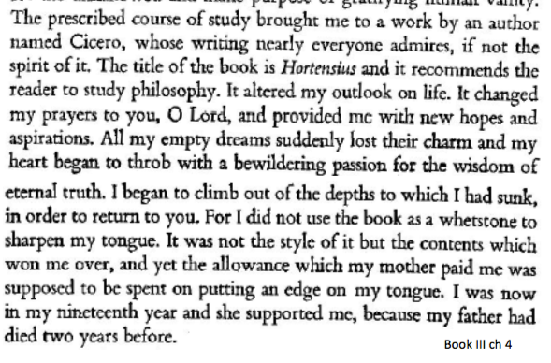

- The first conversion of Augustine was philosophical and it was to befriend wisdom.

* When you study law, you become good at winning an argument; truth isn’t that important. He was studying to become someone who can convince anyone to anything. His conversion went from someone interest in winning a cone to someone interested in wisdom and the truth. So, The truth changed from being tools to becoming ends. You would use the truth to win a conversation vs. after you covert you might lose your life. Theres nothing greater than wisdom.
* His conversion went from someone being a sophist to someone being a socratic.

Sophists- ancient greek teachers of rhetoric philosophy

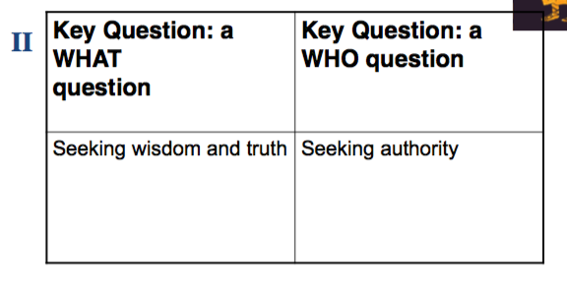

* **Socrates vs the Sophists:**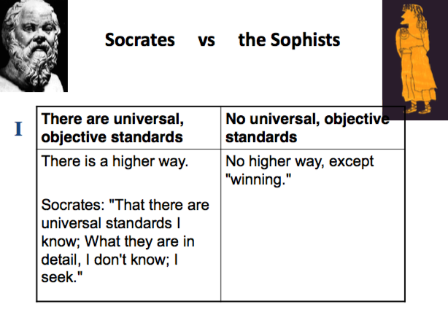

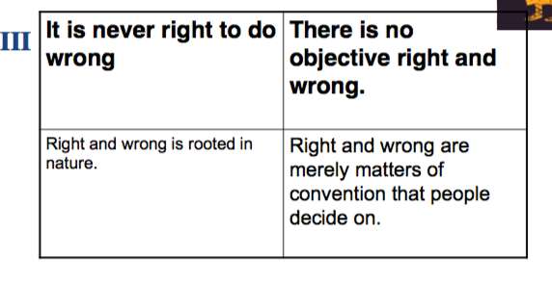

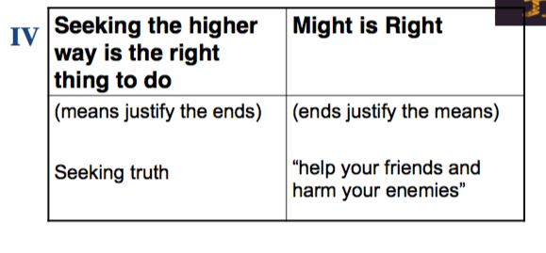

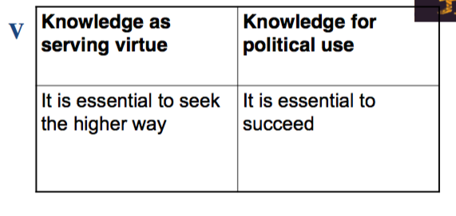

**Conversion is the transformation of an idea into reality.**

* gods; a monotheist would define gods with a small “g” as values because they’re not really there but these values are not perfect values.
* Intellectual conversion of Augustine was from sophist to socratic. 10 years later he underwent his 2nd conversion which was the religious conversion. Augustine was party with a group called the Manichaeans; Manichaeans are dualists. They believed in 2 gods. The Manichaeans ceased to exist after Augustine and part of the reason why because of Augustine himself; what he wrote about Manichaeans. The Manichaeans believed in the spirit and the body, the spiritual god (god of the new testament), the bodily god (god of the old testament/ jewish god/ evil god). Christians do not believe what the Manichaeans believe because they would say there is one God. However, the Manichaeans thought there was this evil God called the God of the Jews and then comes the good God and overwrites the bad teachings of the previous God. Augustine was involved with them even though he didn’t belong to them but he entertained with their ideas. He converted into christianity, he didn’t belong strictly to something. We know exactly what christianity is but there is no real belonging in his story.
* 2 important stories fell on his ears which led him to the 2nd conversion. One is the story of victorious; Augustine went to a friend of his called Simplicianus, a bishop. Simplicianus tells the story of someone called Victorinus; he is someone who underwent a conversion into christianity; he used to say in secret that he’s a christian and he never got baptized, he didn’t want to offend the people around him. He was professor of rhetoric, Augustine was a student of rhetoric. At a later stage, he got baptized and became a christian. Usually you get baptized in public. N particular cases, it is possible to go for a primate session for baptism. But victorinus did it publicly and made a huge sermon and explained why he wants to become a christian. This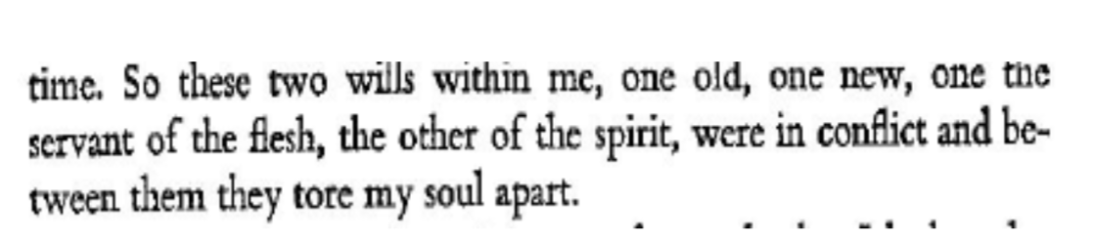 story fell on Augustine’s ears and puzzled him.
* **Struggle within Augustine: He’s talking about the weaknesses of the infected will. Theres something in the human that wants god and his values and something else that would reject that.**
* 2nd story that fell on Augustine’s ears: his friend Alypius and Augustine were visited by another friend called Ponticanus who told them about Saint Anthony and the monastic movement which is: Anthony founded the monastic movement. All of the monks and the religious orders in all of the christian churches are all descendants of Anthony and he started this monastic movement that is based on 3 vows: one is to live in total **obedience**, two is **poverty**; they don’t need any money for their individual own, third they aren’t **allowed to get married or have any sexual activity.** The monastic life begins with Anthony, Anthony structures it. He came from a wealthy family and at his dad’s funeral he said that I’m standing in front of a body that left the world not knowing where it’s going however thats not what I want to do, I want to know where I go.
* The story and convergence of Anthony fell on the ears of Augustine; but it had not yet made the other impact such as education.
* In augustines heart, “give me chastity and continence but not yet.” Something in him is seeing beauty in this life but something else is saying not yet as if there is a truth there that is hidden. One of the things that make Augustine easy to attack and at the same time very great is the fact that he’s too frank. He’s saying that he has a desire for a beautiful chest life but at the same time he’s saying not yet.
* Nature’s appetite is pleasure. Nature is actually philosophy. Nature could be a romantic place. The power of christ would over ride nature and nature’s appetite.

**Phenomenology:**

* Images can be a new reality for us.
* Phenomenology: distinction between a thing and its image.

Its a movement that begins by Edina husserl. Thing and image could be history writing and events…

* Some notes on phenomenology:
* not an abstraction
* Not a branch of philosophy (methodology that penetrates all branches)
* Assumes 4 elements: thing, person, portion of that thing captured in mind, portion of mind thinking of that thing.
* Phenomenology is a distinction between a thing and its image
* Sometimes image could deceive. Phenomenology is meant to be not deceptive but the phenomenologists agree that the thing and the thing’s image are not always represented for various reasons, could be for limitations.
* Phenomenology in history; there could be two definitions history. There is what has been written vs what actually happened. Whats the relationship between that? usually, the more important things are selected, the lesser important things are misdoubt, and the non important things are kept.
* Shadows are representations, image, projection of a certain reality and thats plato’s phenomenology. 1 source of phenomenology could be plato; no one created a system out of it before Husserl.
* “Everything we see hides another thing, we always want to see what is hidden by what we see”- Rene Magritte —> secondary sources quite often could hide the secondary sources.
* Primary sources are usually the oldest sources; secondary sources are nothing more than based on the primary sources. Whereas primary sources, they are the earliest thing that we have. You might have 10 different secondary sources.
* “Only thought can resemble. It resembles by being what it sees
* The jewish speaks of humans being created on the image of god; christian adopt the same testimony, and the islam doesn’t have an image of god. Greeks would say there is the cosmos, and there is the micro cosmos, within every human being theres a universe. Within the human person, there is good, evil, value, love, hate, regret, enjoy, sin, believe, all of these are various modalities in a person’s life. You can also see a phenomenological trait whether
* Augustine himself is one important piece of history in phenomenology… god doesn’t change but time changes. God cant be a moist god because time keeps unchanging by definition or else it wouldn’t be time. What are the 3 divisions of time; past, present and future. By eternity we mean time is finite. Eternity is an only present, there is a time for the future, this new time is present there is no twist to the future. Time will remain to be present with no future and no past.
* Memory, attention and expectation:

Augustine says that the mind regulates all three; it regulates partially. The relationship you have with the past is the memory and with the future is with the expectation. My relationship with the present is with the attention.

- Skeptics:

What if all your experiences is an illusion?

Augustine:

Augustine says that there are three things that he is certain about; I exist, I have knowledge, and I am responsible.

* Existence, knowledge and will: these could be taken to be past, present and the future. But existence is self consciousness where I am aware of my existence, the lack of existence of the rock will not make a difference except to a human being. Everything is perceived by the human being. If theres a universe or not, its all in me.

Knowledge based on faith and trust. You can never verify every piece of knowledge that you get. When you sit on a chair, you do not examine every single atom connecting the chair to the ground. You have to trust things, we cant verify everything.

finally, you have the will; what you choose and what you love.

* Triad of Plotinus: the universal intellect, the one, the world soul. There are quite similar for Augustine to build his trinity.
* Christian trinity: Existence, knowledge, will—-> I am, logos, spirit.
* Will is associated with spirit; by spirit we mean an atmosphere of freedom. From a monotheistic view, will could be a being. Where is the will? Its in some spirit, its a spirit of freedom.
* “There are three things, all found….. what he finds”